**Name_________________________________________**

**Home & Career Skills 6th grade**

**SEWING TOOLS**

Identify each sewing tool and write the proper name below each picture. ***Use your notes for proper spelling.***

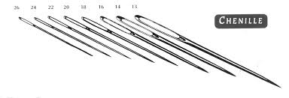

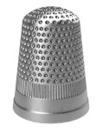

1._____________________________ 2.___________________________

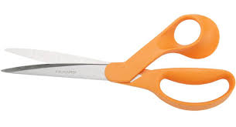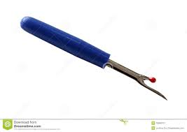

3._____________________________ 4.___________________________

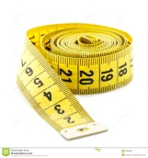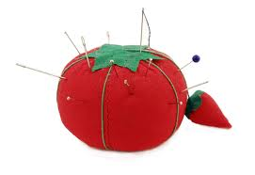

5._____________________________ 6.____________________________

Use the tools that you identified above in question 1-6 to answer questions 7-10.

***Use correct spelling from your notes.***

7. ______________________________- used to hold straight pins.

8. ______________________________- used to measure.

9. ______________________________- wore on your finger to protect it while

hand sewing.

10. _____________________________- helps remove unwanted stitches.